***PROBLEM OF THE WEEK – 04***

***Assignment Given: 05/11/2020***

***Assignment Completed: 21/12/20***

**PROJECT DISCRIPTION: Write or create a C++ or Python or QML based QT application which has a GUI to perform below operations.**

|  |
| --- |
| **Use-Case 1): GUI with a small search bar and dialog box to enter hashtag defined news search in the web.**  **Note: GUI should have Internet Connection.**  **Use-Case 2): GUI takes user input, source and searched the keyword entered with # in the web and retrieves the latest news, if 2 hashtags are separated by comma then it should give news with those tags keywords combined search.**  **Note:** After search is clicked the action should open new window on the same application with news link and small description of it.  **Use-Case 3):** Once the user clicks on the headline or the link of the news he wants to read it should open a new window for displaying the full article.  **Note:** Sorting should be done by new to old based on Time of published.  **Use-Case 4):** Once the user clicks Scroll option the headline or article loaded should scrolling slow motion and reach or stop at the end of list or news.  **Note:** Scrolling should be done in headline page and new window of article page.  **Use-Case 5):** The application should also generate Performance report consisting of Average CPU, memory, of both process of the application and also from the system during the APP run time and generate a csv storing the values. Once the user clicks on the headline or the link of the news he wants to read it should open a new window for displaying the full article.  **Note:** Data from analysis should be in % for CPU and MB (Megabytes) for Memory. |

**Note:**

1. Try to use the in-Built C++or QML or Python functions and methods.
2. Make all necessary comments and display message corresponding to invalid inputs.
3. Create a Log file for all the operations performed.

**Program/APP screenshot:**

1. **Mainwindow.ui:**

(Default its selected Indian Express as News Source)

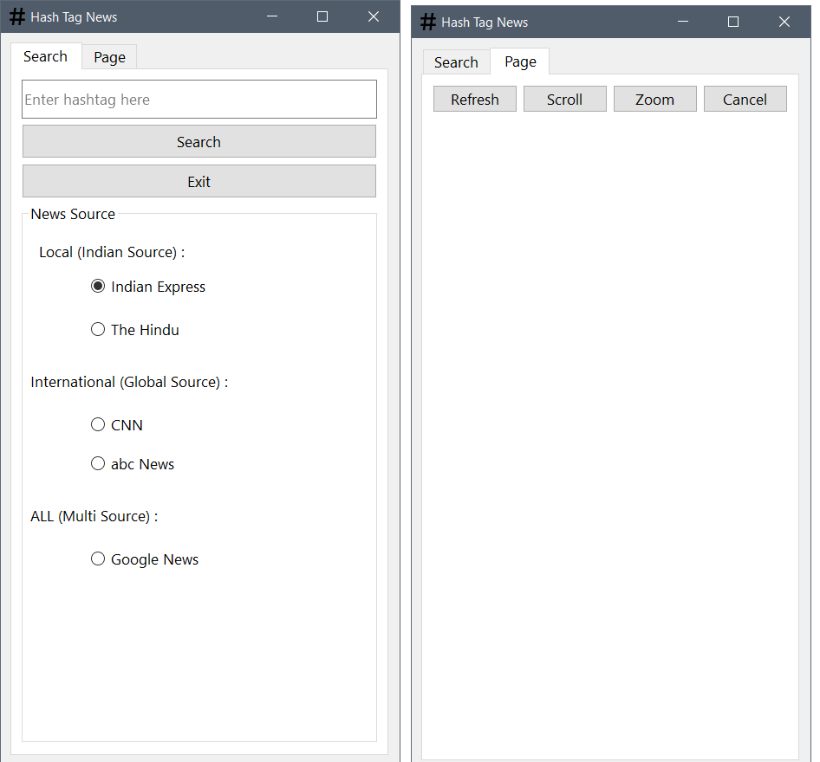

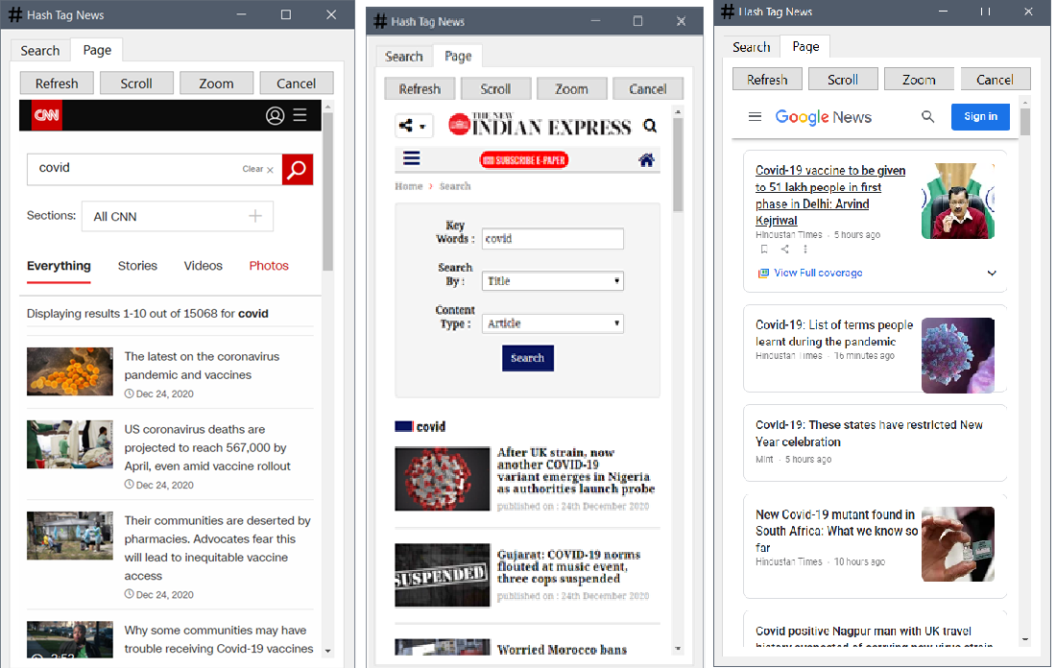

Searching a hashtag with 3 different news sources and the results are shown in second tab containing the refresh, scroll, zoom, and cancel option to perform the actions on main window of the application.

* News loaded by selecting different Radio buttons in the UI.
* All are sorted in the descending order of their published time.
* CNN, INDIAN EXPRESS, GOOGLE NEWS are loaded.

1. **Dialog.ui:**

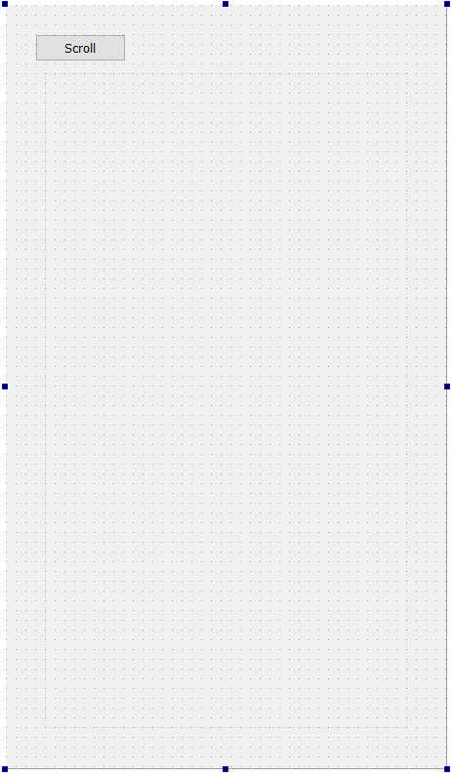

New dialog contains only one button scroll. This is opened when a user clicks the article from then loaded headlines and the app fetches the link and opens in this new window. Scrolling the article in the slow mode for the allow user to read the full article since the since length can’t be determined only default has been kept.

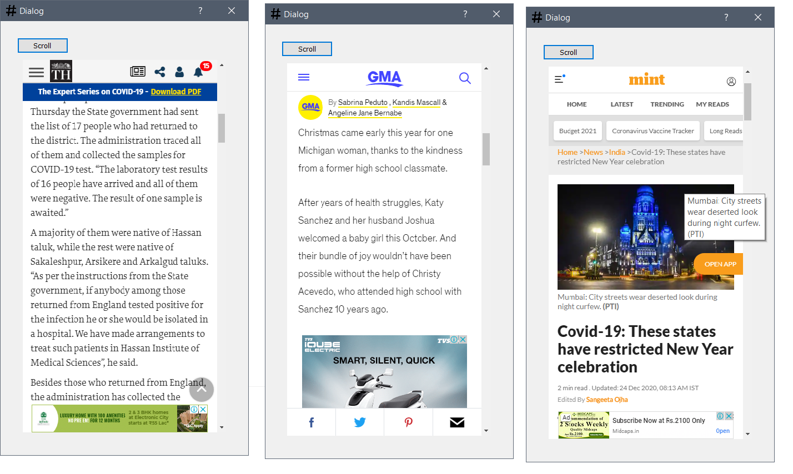

The News articles loaded from the news source is for the user to read it. Scroll button is the only option give to user by the application.

1. **Logfile:**

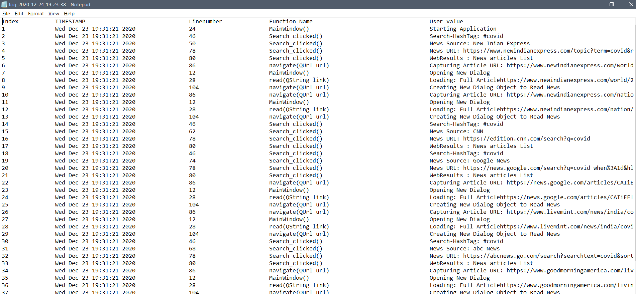

1. **Performance report:**

